PRESS RELEASE
29th March 2021
For immediate release

LUCY DREAMING EASTER EGG HUNT GIVES
PLAYERS THE CHANCE TO APPEAR IN THE FULL GAME
Find their hidden Easter egg, and Tall Story Games will turn you into a pixel-art NPC!

Tall Story Games’ new demo for their point & click adventure Lucy Dreaming contains a well-hidden Easter egg that unlocks the chance to win big. Its discovery offers adventure gamers a once-in-a-lifetime chance to appear as a pixel-art character in the full release of the game.
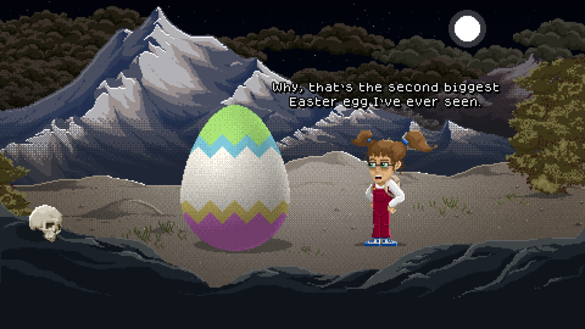
Every player who finds the Easter egg is offered the chance to enter a draw where the prize is unlike any other – become an NCP (non-player character) in the full game! Not only will their likeness be rendered seamlessly into the beautiful, retro pixel-art world of Lucy Dreaming, they will also become an integral part of the game’s story and gameplay. In addition to this, the winner will receive a free digital copy of the full game, a high-resolution digital artwork of their character and a mention in the game’s credits to boot.
Tall Story Games’ Tom Hardwidge said “I absolutely LOVE Easter eggs in games myself, from little nods and meta-references to full-blown competitions like this. We launched the demo in early March, but it seemed appropriate to announce this search at Easter. As a kid playing the adventure games back in the 90s, it was always a thrill to discover things in games that were well-hidden, as if they were put there just for you by the game’s creator.”
Lucy Dreaming is a comedic, quirky point & click adventure which sees players taking control of the destiny of Lucy, a young girl suffering from recurring nightmares. In the game Lucy unlocks the secrets to controlling her dreams and journeys through a myriad of weird & wonderful locations in both the real world and her dreams. On the way she encounters a cast of extraordinary characters and creatures as she unearths the disturbing truth behind her nightmares.
The free demo is a 30-60 minute prequel for the full Lucy Dreaming game which will launch later in 2022. Tall Story Games are launching a Kickstarter to fund the development of the full game in May 2021.
Full details can be found on the Lucy Dreaming website: https://lucy-dreaming.com/egg/
The demo is available for Windows, MacOS and Linux via Steam and Itch.io, so what are you waiting for? Go and find that egg!
ENDS

For more information contact
Tom Hardwidge: tom@tallstorygames.com Tel: 07792 550 888
Download the free demo
Available for Windows, MacOS and Linux.
Steam: https://store.steampowered.com/app/1532710/Lucy_Dreaming/
Itch.io: https://tallstorygames.itch.io/lucy-dreaming
Follow the Kickstarter
You can follow the game’s Kickstarter campaign from the pre-launch page: https://www.kickstarter.com/projects/hardwidge/lucy-dreaming-a-pixel-art-point-and-click-comedy-adventure
Useful links
Website: lucy-dreaming.com
Easter egg hunt: lucy-dreaming.com/egg
Social media: Twitter | Facebook | Instagram | YouTube
Steam: https://store.steampowered.com/app/1532710/Lucy_Dreaming/
Itch.io: https://tallstorygames.itch.io/lucy-dreaming
Kickstarter: https://www.kickstarter.com/projects/hardwidge/lucy-dreaming-a-pixel-art-point-and-click-comedy-adventure
Press kit: lucy-dreaming.com/press
About Tall Story Games
Lucy Dreaming is the first full-length title to be produced by the newly-founded indie game studio Tall Story Games. The founders, Tom and Emma Hardwidge, are a husband and wife team based in Shropshire, England specialising in narrative-driven games. They have a strong focus on creating games with engaging stories, well-developed characters and above all a good sense of humour.
Tall Story Games has already created a series of shorter titles which have been very well received within the adventure game community. Last year the team produced “Hair of the Dog” which followed a member of the Victorian gentry as he investigates the mysterious disappearance of his uncle, and “Lockdown”, an HTML-based point & click game where a virologist balances her work, parenting and home schooling while confined to her home.
In 2019, they also produced “Where’s my Cloak?” for the Roman Baths, Bath. This was the team’s first adventure game project and was the catalyst that brought them to where they are now.
Website: tallstorygames.com
Social media: Twitter | Facebook | Instagram | YouTube
Previous games.
- Hair of the Dog: tallstorygames.com/portfolio/hair-of-the-dog
- Lockdown: tallstorygames.com/portfolio/lockdown/
- Where’s my Cloak?: tallstorygames.com/portfolio/wheres-my-cloak/

