PRESS RELEASE
FOR IMMEDIATE RELEASE

Do you dream of a return to the 90s?
This new Kickstarter can make it happen!
Do you have the necessary skills to survive a 90s nostalgia-trip? Retro point & click adventure ‘Lucy Dreaming’ hits you right in the childhood!
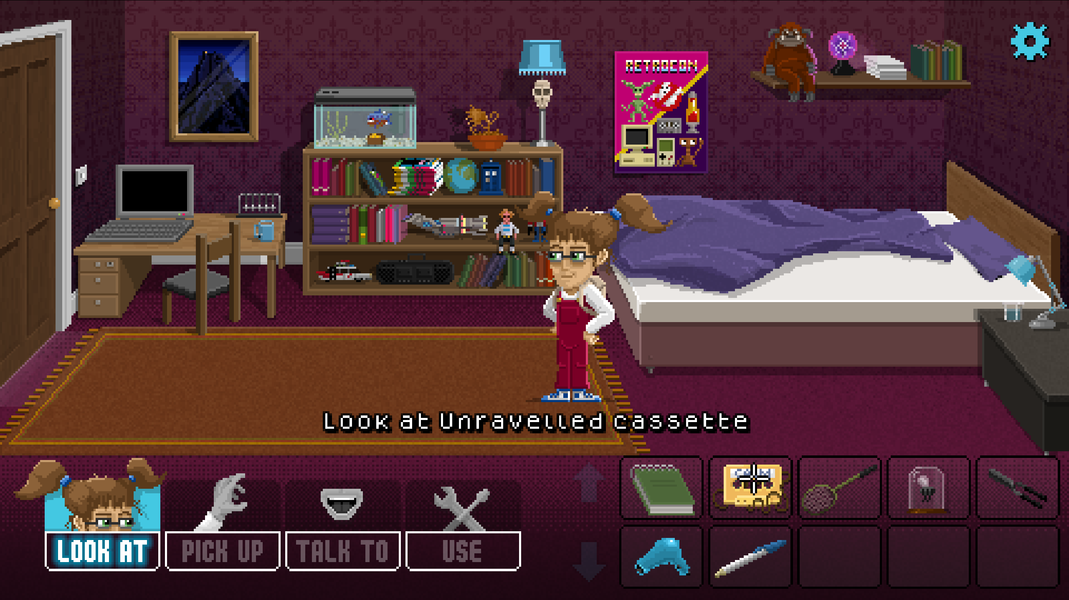
If you know the secret of getting magnetic tape back into a cassette, have experience rescuing small mammals from the wrong end of a blunderbuss, or just loved playing classic LucasArts adventures in the 90s then Lucy Dreaming will delight you.
Nostalgic pixel-art and a thoroughly British sense of humour take you on a hilarious adventure through dreams and reality. Discover a cast of dysfunctional characters as you unearth the disturbing truth behind retro-obsessed Lucy’s recurring nightmare.
Imagine Inception, just with more warm milk, badgers, and experimental groin surgery.
Don’t just play it. Support Lucy Dreaming on Kickstarter before 26th May and you can be part of the action too. Tall Story Games are offering backers the chance to appear in the game as pixel-art NPCs as well as a host of other rewards including a Deluxe Collector’s Box, a retro USB cassette and hand-drawn concept art.
A 30-60 minute spoiler-free demo is available for Windows, MacOS, Linux and Android, so reward your inner-child with a short adventure before heading over to Kickstarter to help make this dream a reality.
ENDS
For more information contact
Tom Hardwidge
hello@tallstorygames.com | +44(0)7792 550 888 / +44(0)1952 882342

Demo on Steam: Lucy Dreaming on Steam
Demo on Google Play Store: Lucy Dreaming on Android

Press kit: lucy-dreaming.com/press
Website: lucy-dreaming.com
Social media: Twitter | Facebook | Instagram | YouTube
Kickstarter: Kickstarter


About Tall Story Games
Lucy Dreaming is the first full-length title to be produced by the newly-founded indie game studio Tall Story Games Ltd. The founders, Tom and Emma Hardwidge, are a husband and wife team based in Shropshire, England specialising in narrative-driven games. They have a strong focus on creating games with engaging stories, well-developed characters and above all a good sense of humour.
Tall Story Games has already created a series of shorter titles which have been very well received within the adventure game community. Last year the team produced “Hair of the Dog” which followed a member of the Victorian gentry as he investigates the mysterious disappearance of his uncle, and “Lockdown”, an HTML-based point & click game where a virologist balances her work, parenting and home schooling while confined to her home.
In 2019, they also produced “Where’s my Cloak?” for the Roman Baths, Bath. This was the team’s first adventure game project and was the catalyst that brought them to where they are now.
Website: tallstorygames.com
Social media: Twitter | Facebook | Instagram | YouTube

Other games.
- Hair of the Dog: tallstorygames.com/portfolio/hair-of-the-dog
- Lockdown: tallstorygames.com/portfolio/lockdown/
- Where’s my Cloak?: tallstorygames.com/portfolio/wheres-my-cloak/

