PRESS RELEASE
FOR IMMEDIATE RELEASE

Lucy Dreaming Funds in just One Week!
Who said adventure games are dead?
Lucy Dreaming proves you should never give up on your dreams.
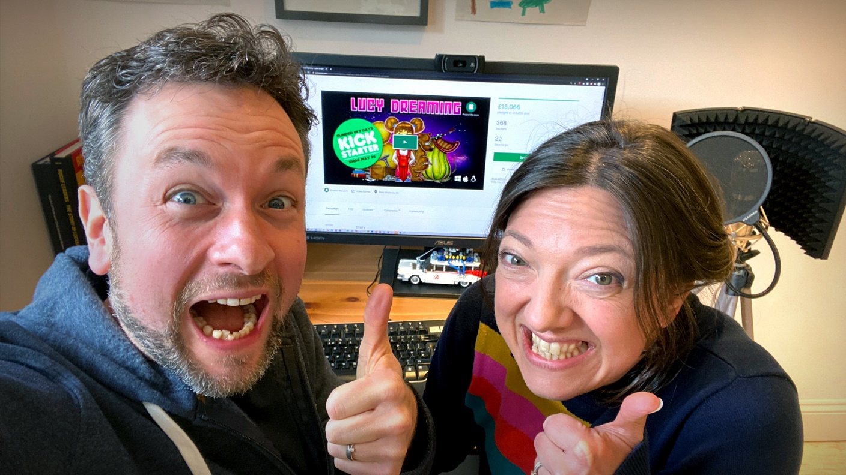
Immediately after launching a Kickstarter campaign to fund their retro point & click adventure Lucy Dreaming, Tall Story Games couldn’t believe it when adventure game fans from around the globe turned up to pledge their support, and the funding amount just kept on going up.
After being hand-picked as one of Kickstarter’s “Projects we Love”, husband and wife team Tom and Emma Hardwidge achieved their initial funding goal within just one week, and it hasn’t stopped there. They are already well on their way to reaching their first stretch goal which sees the game’s colourful cast fully-voiced.
Despite warnings from naysayers early on that the adventure games industry was “on its knees”, the couple decided to pursue their dream and put their pixel-art point & click demo out into the world to let the public decide.
“We’ve been utterly overwhelmed and delighted by the support we’ve had from adventure game fans all around the world.” said founder Tom Hardwidge ”The idea that a genre that’s brought so much joy to millions of players for decades could just disappear didn’t ring true to us.”
Lucy Dreaming follows in the footsteps of a number of point & click adventures which have successfully crowdfunded recently, and the gaming community is taking notice of the indie developers who share their passion for narrative-driven games.
Lucy Dreaming is a comedic, quirky point & click adventure which sees players taking control of the destiny of Lucy, a young girl suffering from recurring nightmares. In the game Lucy unlocks the secrets to controlling her dreams and journeys through a myriad of weird & wonderful locations in both the dream world and reality. On the way she encounters a cast of extraordinary characters and creatures as she unearths the disturbing truth behind her nightmares.
If you know the secret of getting magnetic tape back into a cassette, have experience rescuing small mammals from the wrong end of a blunderbuss, or just loved playing classic LucasArts adventures in the 90s then Lucy Dreaming will delight you.
Nostalgic pixel-art and a thoroughly British sense of humour take you on a hilarious adventure through dreams and reality. Discover a cast of dysfunctional characters as you unearth the disturbing truth behind retro-obsessed Lucy’s recurring nightmare.
Imagine Inception, just with more warm milk, badgers, and experimental groin surgery.
Don’t just play it. Support Lucy Dreaming on Kickstarter before 26th May and you can be part of the action too. Tall Story Games are offering backers the chance to appear in the game as pixel-art, as well as a host of other rewards including a Deluxe Collector’s Box, a retro USB cassette and hand-drawn concept art.
A 30-60 minute spoiler-free demo is available for Windows, MacOS, Linux and Android, so reward your inner-child with a short adventure before heading over to Kickstarter to help make this dream a reality.
ENDS
For more information contact
Tom Hardwidge
hello@tallstorygames.com | +44(0)7792 550 888 / +44(0)1952 882342

Demo on Steam: Lucy Dreaming on Steam
Demo on Google Play Store: Lucy Dreaming on Android

Press kit: lucy-dreaming.com/press
Website: lucy-dreaming.com
Social media: Twitter | Facebook | Instagram | YouTube
Kickstarter: Kickstarter

About Tall Story Games
Lucy Dreaming is the first full-length title to be produced by the newly-founded indie game studio Tall Story Games Ltd. The founders, Tom and Emma Hardwidge, are a husband and wife team based in Shropshire, England specialising in narrative-driven games. They have a strong focus on creating games with engaging stories, well-developed characters and above all a good sense of humour.
Tall Story Games has already created a series of shorter titles which have been very well received within the adventure game community. Last year the team produced “Hair of the Dog” which followed a member of the Victorian gentry as he investigates the mysterious disappearance of his uncle, and “Lockdown”, an HTML-based point & click game where a virologist balances her work, parenting and home schooling while confined to her home.
In 2019, they also produced “Where’s my Cloak?” for the Roman Baths, Bath. This was the team’s first adventure game project and was the catalyst that brought them to where they are now.
Website: tallstorygames.com
Social media: Twitter | Facebook | Instagram | YouTube

Other games.
- Hair of the Dog: tallstorygames.com/portfolio/hair-of-the-dog
- Lockdown: tallstorygames.com/portfolio/lockdown/
- Where’s my Cloak?: tallstorygames.com/portfolio/wheres-my-cloak/

